1. Implement and demonstrate the FIND-S algorithm for finding the most specific hypothesis based on a given set of training data samples.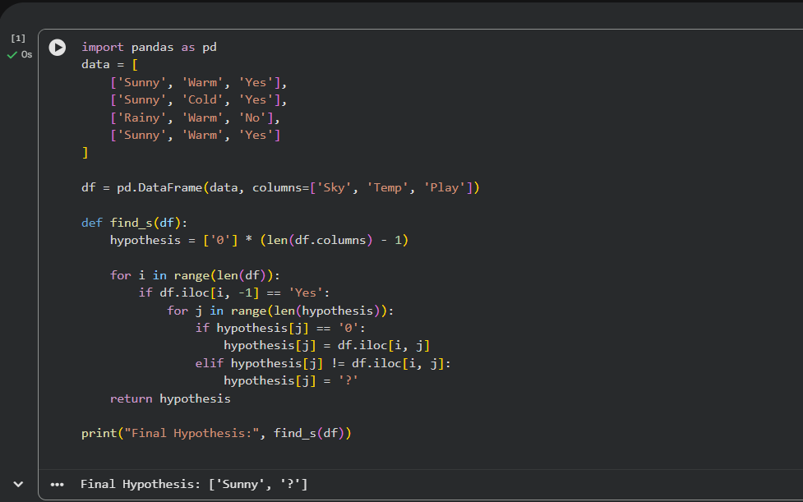

2. For a given set of training data examples stored in a .CSV file, implement and demonstrate the Candidate-Elimination algorithm in python to output a description of the set of all hypotheses consistent with the training examples
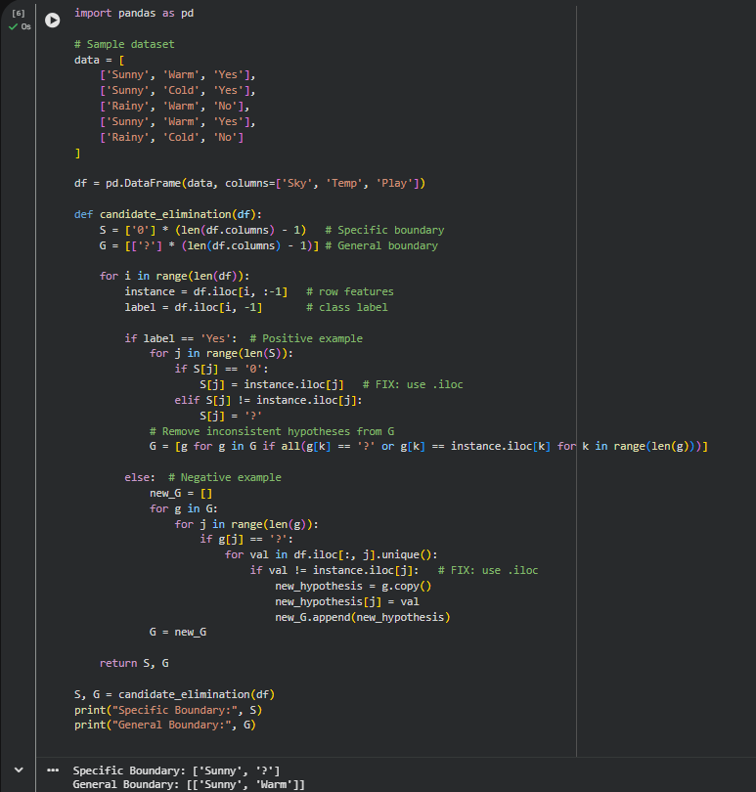

3. Demonstrate the working of the decision tree based ID3 algorithm. Use an appropriate data set for building the decision tree and apply this knowledge to classify a new sample.

